**Cloud computing: Overview**

Cloud computing is a transformative technology that has revolutionized the way businesses and individuals access and manage computing resources, data, and applications. It involves the delivery of computing services over the internet, allowing users to access and use these resources as needed without the need for extensive on-premises infrastructure.

**Key Concepts of Cloud Computing:**

* On-Demand Access: Cloud computing provides on-demand access to a wide range of computing resources, including virtual machines, storage, databases, networking, and more. Users can provision and de-provision resources as needed, paying only for what they use.
* Service Models: Cloud computing offers various service models, including Infrastructure as a Service (IaaS), Platform as a Service (PaaS), and Software as a Service (SaaS). These models provide different levels of control and management for users.
* Deployment Models: Cloud services can be deployed in several ways, such as Public Cloud (accessible to the general public), Private Cloud (dedicated to a single organization), Hybrid Cloud (a combination of public and private clouds), and Community Cloud (shared by multiple organizations with common interests).
* Scalability: Cloud services are designed for scalability, allowing users to easily scale resources up or down to accommodate changing workloads and demand.
* Pay-as-You-Go Pricing: Users are billed based on their actual usage, which can lead to cost savings by eliminating the need to invest in and maintain costly on-premises hardware.
* Resource Pooling: Cloud providers aggregate computing resources to serve multiple customers, effectively sharing infrastructure while maintaining security and isolation.
* Self-Service: Users can provision and manage resources independently through web-based interfaces, APIs, or command-line tools, reducing the need for direct IT involvement.

**Service Models in Cloud Computing:** Cloud service models are the different ways that cloud computing services can be delivered. The three most common cloud service models are:

* Infrastructure as a Service (IaaS): IaaS provides virtualized computing resources over the internet. Users can access and manage virtual machines, storage, and networking components. Popular IaaS providers include Amazon Web Services (AWS), Microsoft Azure, and Google Cloud Platform (GCP).
* Platform as a Service (PaaS): PaaS offers a platform that allows developers to build, deploy, and manage applications without worrying about the underlying infrastructure. The PaaS provider takes care of the infrastructure, while the customer focuses on building and running their applications. Common PaaS providers include Heroku, Google App Engine, and Red Hat OpenShift.
* Software as a Service (SaaS): provides businesses with access to software applications that are hosted and managed by the SaaS provider. SaaS customers access the applications over the internet using a web browser or mobile app, eliminating the need for local installations and maintenance. Examples include Microsoft Office 365, Salesforce, and Google Workspace.

Which cloud service model is right for a business depends on its specific needs and requirements. Businesses that need a high degree of control over their infrastructure and applications may prefer IaaS. Businesses that want to focus on building and running their applications without having to worry about managing the underlying infrastructure may prefer PaaS. Businesses that need access to software applications that are hosted and managed by the cloud provider may prefer SaaS.

Here are some examples of how businesses are using the different cloud service models:

* IaaS: A small business may use IaaS to host its website and email server. The business can rent virtual machines from an IaaS provider and then install its own software on the VMs.
* PaaS: A startup may use PaaS to develop and deploy its web application. The startup can use a PaaS platform to provision the necessary resources, such as a web server and database, and then deploy its application to the platform.
* SaaS: A large enterprise may use SaaS to manage its customer relationship management (CRM). The enterprise can subscribe to a SaaS-based CRM application and then access the application over the internet using a web browser or mobile app.

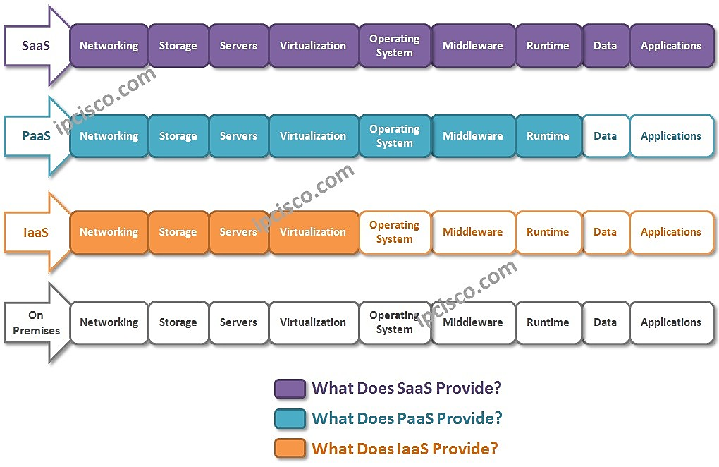

**Cloud computing layers:** Cloud Computing can be divided intothe following four layers:

* **Application Layer** is the Layer of SaaS (Infrastructure as a Service). Here, applications and softwares reside. Gmail, Facebook, Youtube, Dropbox etc. use this layer. It is the layer of the users.
* **Platform Layer** is the Layer of PaaS (Platform as a Service). Here, software frameworks reside. Google App Engine, Microsoft Azure etc. use this layer. It is the layer of the developers.
* **Infrastructure Layer** is one of the Layers of IaaS (Infrastructure as a Service). Here, Virtual machines reside. Amazon Web Services, Go Greed, Rack Space are some of the services that we can give working on this layer. It is the layer of the system administrators.
* **Hardware Layer** is another Layer of IaaS (Infrastructure as a Service). Here, Storages, CPUs, memories reside. Any Data Centers can be a good example for this layer. It is again, the layer of the system administrators.

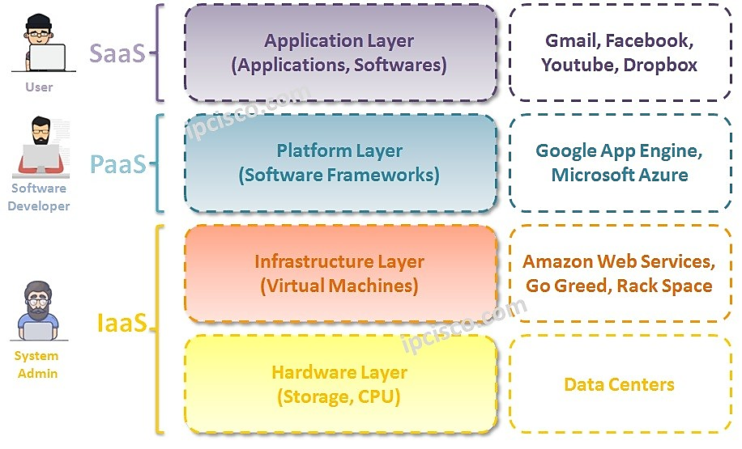

**Benefits of Cloud Computing:**

1. Cost-Efficiency: Cloud computing reduces capital expenses, as users only pay for what they use. It eliminates the need to invest in and maintain on-premises hardware.
2. Scalability: Cloud services can scale up or down based on demand, ensuring optimal resource utilization and performance.
3. Flexibility: Users can choose from a wide range of services and configurations to meet their specific needs.
4. Agility: Cloud computing can help businesses to be more agile and responsive to change. With cloud computing, businesses can quickly provision new resources and deploy new applications without having to invest in their own hardware or software.
5. Reliability: Cloud providers offer reliable and secure services. They have the expertise and resources to keep their services up and running 24/7.
6. Global Reach: Cloud providers offer data centers in various regions worldwide, providing global accessibility and redundancy.
7. Security: Reputable cloud providers implement robust security measures, often surpassing what's achievable with on-premises solutions.
8. Business Continuity: Cloud services support data backup, disaster recovery, and high availability, ensuring business continuity even in adverse situations.

**Challenges and Considerations:**

* Security Concerns: While cloud providers implement strong security measures, data breaches and security incidents can still occur, necessitating proper security strategies.
* Data Privacy and Compliance: Compliance with data privacy regulations like GDPR and HIPAA is critical, and cloud users need to ensure their data handling aligns with these regulations.
* Vendor Lock-In: Migrating away from a cloud provider can be challenging due to dependencies on their services, which can lead to vendor lock-in.
* Downtime and Reliability: Cloud outages can disrupt operations, so users must plan for redundancy and disaster recovery.
* Data Transfer Costs: Data transfer between cloud services and on-premises infrastructure can incur additional charges.

**Use Cases of Cloud Computing:** Cloud computing is used by businesses of all sizes, from small businesses to large enterprises. Some examples of how cloud computing is used include:

* Infrastructure and Application Hosting: Many businesses use cloud-based hosting services to host websites, applications, and databases.
* Data Storage and Backup: Cloud storage solutions provide secure and scalable data storage and backup.
* Development and Testing Environments: Developers use the cloud to create and test applications without investing in local infrastructure.
* IoT (Internet of Things): Cloud services support IoT by collecting, processing, and analyzing data from connected devices.
* Machine Learning and AI: Cloud platforms offer machine learning and artificial intelligence services for training and deploying models.
* Email and collaboration: Many businesses use cloud-based email and collaboration services, such as Gmail and Microsoft 365.
* Customer relationship management (CRM): Many businesses use cloud-based CRM systems to manage their customer interactions and sales pipeline.
* Enterprise resource planning (ERP): Many businesses use cloud-based ERP systems to manage their financial accounting, human resources, and supply chain management.
* Big data and analytics: Many businesses use cloud-based big data and analytics services to collect, store, and analyze large data sets. Cloud computing is instrumental in processing and analyzing large volumes of data, enabling data-driven decision-making.

**Prominent Cloud Service Providers:**

* Amazon Web Services (AWS): The largest and most widely used cloud provider, offering a vast array of services.
* Microsoft Azure: Microsoft's cloud platform with a strong focus on enterprise solutions.
* Google Cloud Platform (GCP): Google's cloud offering, known for its data analytics and machine learning services.
* IBM Cloud: Providing cloud services and enterprise solutions with a focus on hybrid and multi-cloud environments.
* Oracle Cloud: Oracle's cloud services, offering a wide range of database and enterprise applications.

Top of Form

**Knowledge Level 4: Analyze**

**Bloom Keyword: Application**

1. **Analyze the different deployment models of cloud computing, such as public cloud, private cloud, hybrid cloud, and multi-cloud.**
2. **Compare and contrast the different service models of cloud computing, such as Infrastructure as a Service (IaaS), Platform as a Service (PaaS), and Software as a Service (SaaS).**
3. **Evaluate the benefits and challenges of adopting cloud computing for IoT applications.**

**Benefits of adopting cloud computing for IoT applications:**

* **Scalability and flexibility:** Cloud computing provides the ability to scale resources up or down as needed, making it well-suited for the dynamic and fluctuating resource demands of IoT applications. This flexibility allows businesses to adapt to changes in data volume, user activity, and application requirements without significant upfront investments or infrastructure overhauls.
* **Cost-effectiveness:** Cloud computing eliminates the need for organizations to purchase, maintain, and upgrade on-premises hardware and software, which can significantly reduce IT infrastructure costs. Cloud providers handle the underlying infrastructure, including servers, storage, and network connectivity, allowing businesses to focus on their core competencies and application development.
* **Reduced complexity:** Cloud computing simplifies the management and operation of IoT applications, as cloud providers handle the underlying infrastructure and provide tools for managing virtual machines, data storage, and application deployment. This reduces the burden on IT teams and allows them to focus on more strategic tasks.
* **Improved accessibility:** Cloud-based IoT applications can be accessed from anywhere with an internet connection, enabling remote monitoring, control, and data analysis. This flexibility is particularly valuable for IoT applications deployed in remote or geographically dispersed locations.
* **Enhanced security:** Cloud providers typically employ robust security measures, such as encryption, access control, and intrusion detection systems, to protect data and applications. This can be a significant advantage for IoT applications, which often handle sensitive data and require stringent security measures.

**Challenges of adopting cloud computing for IoT applications:**

* **Vendor lock-in:** Reliance on a single cloud provider can lead to vendor lock-in, making it difficult to switch providers or migrate applications to other platforms. This can increase costs and limit flexibility in the long run.
* **Data security and privacy:** IoT applications often collect and generate vast amounts of sensitive data, which raises concerns about data security and privacy. Businesses must carefully evaluate the security measures and data privacy practices of cloud providers to ensure their data is adequately protected.
* **Network latency and reliability:** The performance of cloud-based IoT applications can be affected by network latency and reliability issues. Applications that require real-time data processing or low-latency responses may face challenges in a cloud environment.
* **Integration with existing systems:** Integrating IoT applications with existing on-premises systems can be challenging, requiring additional effort and expertise to ensure compatibility and seamless data exchange.
* **Compliance with regulations:** IoT applications may need to comply with specific industry regulations or data privacy laws, which can add complexity to cloud deployment and require careful consideration of the provider's compliance capabilities.

1. **Discuss the key security and privacy considerations when using cloud computing services.**
2. **Identify and analyze the different cloud computing providers and their respective offerings.**

**Knowledge Level 5: Evaluate**

**Bloom Keyword: Evaluation**

1. **Critically evaluate the suitability of cloud computing for specific business applications and scenarios.**
2. **Assess the potential impact of cloud computing on the future of IT infrastructure and services delivery.**
3. **Develop a framework for selecting the most appropriate cloud computing provider and service model for a given organization.**
4. **Propose a strategy for migrating existing IT infrastructure and applications to the cloud.**
5. **Discuss the ethical and legal implications of cloud computing, such as data ownership, privacy, and jurisdiction.**